ASSIGNMENT 2

Note: I did a couple changes on a separate branch but it did not work as a separate branch which was weird. It acted like one, and merged but did not actually show as a separate branch. It even gave me an error saying ‘branch “changes” already exists’ when I tried to re-create it. Because of that I did only one small change on a separate branch and merged it, since this was a requirement. Here is a screenshot, I think it crested a virtual branch (if those exist) because it was comparing master to master :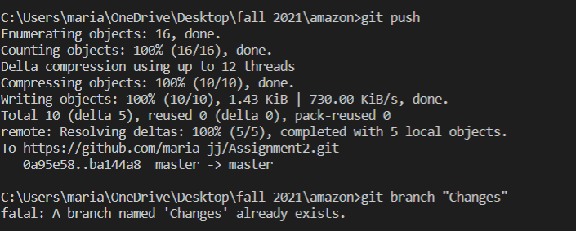

The website I chose was amazon.ca, and i made the home page and product description page. I created components like button, nav bar (containing empty links apart from 1 - the ‘all’ link which takes you back to home page to allow navigation from product description back to home), header, footer, product card, products. The reason i created those is because the header, navbar, and footer are main components of the amazon website, and would give the look and feel of that site (even if the header and footer links are empty). The product card was created to contain description of the product as well as buttons such as add to cart. This component is reusable because it acts like a template since amazon has multiple products (the values were later defined in app.js).